**WCF Service in IIS**

The following example shows a way to Host a WCF service in IIS and consume it in the client through Jquery.Ajax. This concept shall be implemented in DLS when it talks to external services like AAMVA,

VLS, DIVS, etc. Please note: The end point used in the WCF service is “webHttpBinding”.

**Step 1:** Create a WCF service application

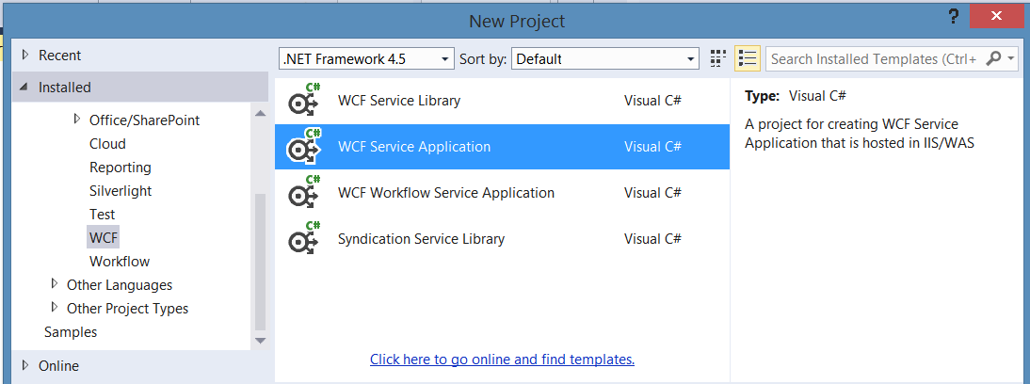

**Step 2:** Create a Service Interface. Add a new class file and name it as IMath.cs.

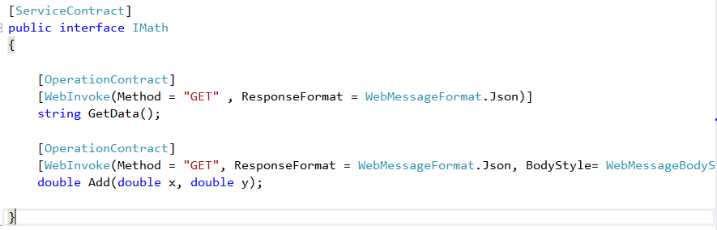

**Step 3:** Implement the IMath interface in Math.svc

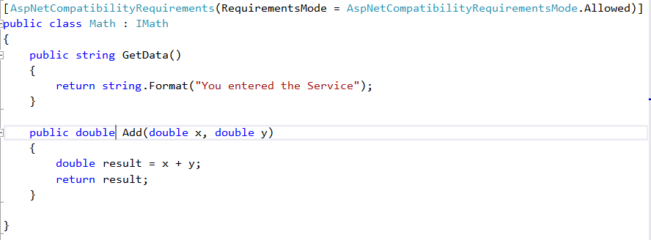

**Step 4:** Define endpoint in Web.config. Please note the binding used here is “webHttpBinding”

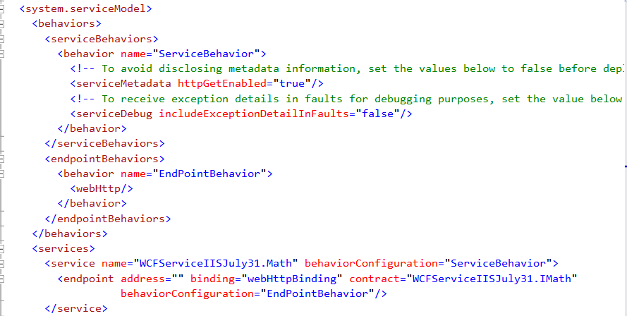



**Step 5: Publish the service to host it in IIS using Web publish**

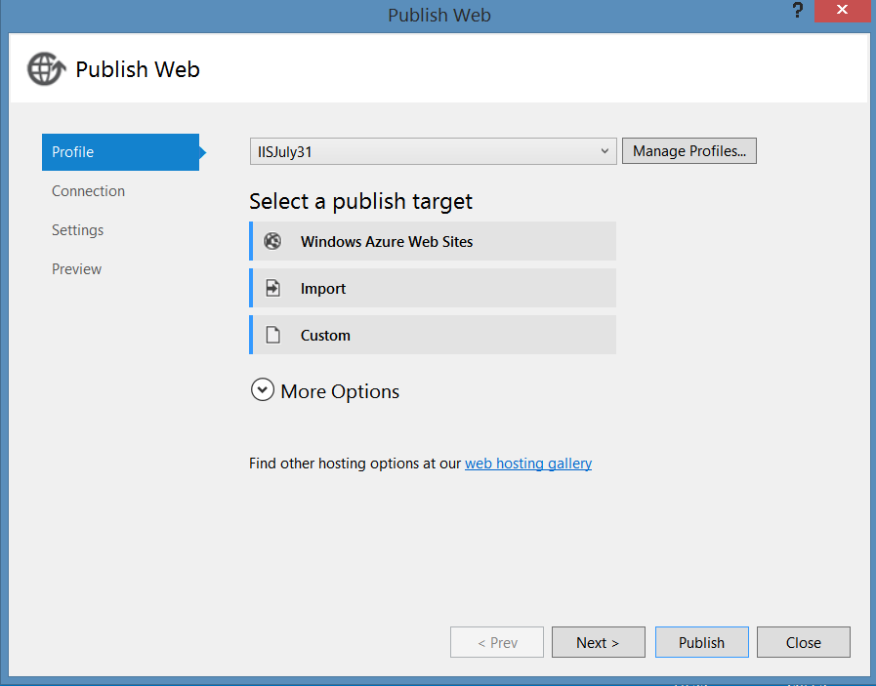

**Step 6:** Download and install Web Deploy 3.5 in IIS. This has seamless Integration with IIS Manager for creating packages and deploying them onto a machine, both locally and remotely.

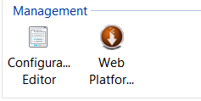

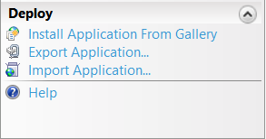

**Step 7: Host the Service in IIS**

Map the path of the published Zip file and name it as “WCFServiceIISJuly31”**.**

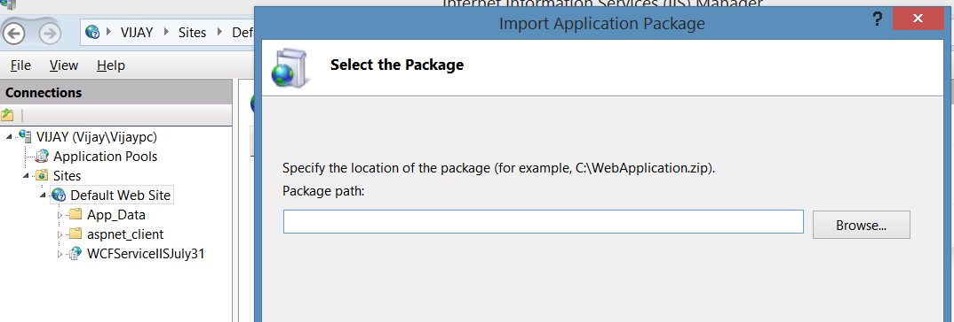

**Browse the hosted Service**

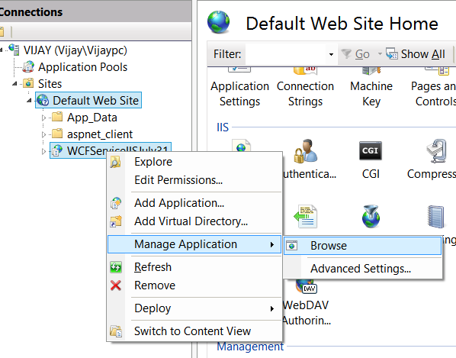

**This will bring up the service hosted in IIS as,**

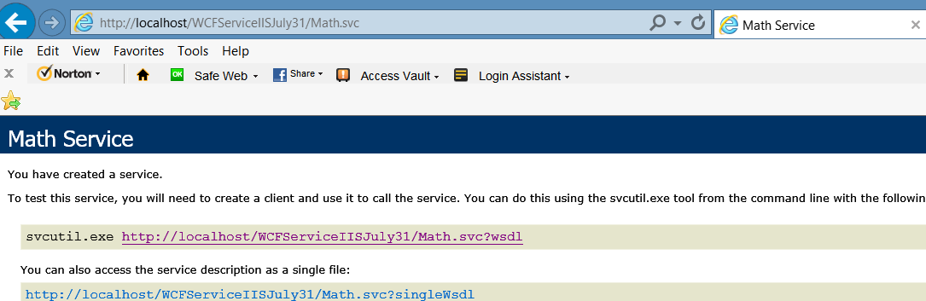

**Step 8: Call the Windows service ADD method through AJAX in a MVC view using Jquery.ajax ().**

$.ajax({

type: "GET",

processData: true,

data: "{}",

url: "http://localhost/WCFServiceIISJuly31/Math.svc/Add?x=50&y=51",

contentType: "application/json; charset=utf-8",

dataType: "json",

success: function (result) {

var data = JSON.stringify(result);

var obj = $.parseJSON(data);

$('#lblText1').text(obj.AddResult);

},

error: function (error) {

alert('Hi failure');

alert(error);

}

});